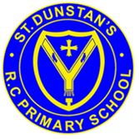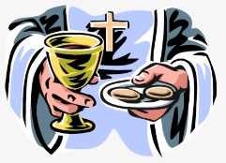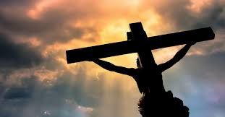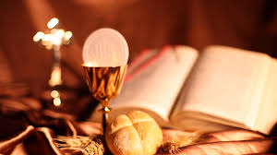

**SCRIPTURE**

**Exodus 13: 3** Moses said to the people, “Remember this day, the day you left Egypt. You were slaves in that land. The Lord with his great power brought you out of it. You must not eat bread made with yeast.

**Luke 22: 14-20** **Jesus took some bread. He thanked God for it, broke it, and gave it to the apostles. Then Jesus said, “This bread is my body that I am giving for you. Do this to remember me.” In the same way, after supper, Jesus took the cup and said, “This cup shows the new agreement that God makes with his people. This new agreement begins with my blood which is poured out for you.”**

**OUR BIG QUESTION**

Why do we need memories?

**KEY VOCABULARY**

Memorial sacrifice Passover Pesach chalice Eucharist consecration genuflect

**REFLECTION**

Lord Jesus Christ, in you we know the love of God. When we gather in your name, we experience the marvel of your loving presence which challenges us to live for one another. Help us to follow your example so that we may never become complacent. Help us to listen to your constant call to us to continue the work you began, you who lived and died for us. Grant this through your Spirit of Love.

Amen.

The Eucharist is a memorial of Christ’s sacrifice on the Cross.

Christ gives his body and blood for the salvation of all people and provides hope for the future.

The Eucharist is a memorial sacrifice in the Jewish sense of remembering, that is it makes present a past reality.

**MEMORIAL SACRIFICE**

Year 5 Topic 5