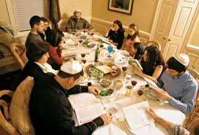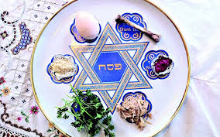

The name Passover comes from the story of the angel of death passing over the house of the Israelites.

Hospitality is important at Pesach.

It is a time people thank God for their freedom.

Pesach or Passover is a spring festival which lasts for 7 or 8 days.

**OUR BIG QUESTION**

Why would Jews want to celebrate Pesach in Jerusalem?

Pesach comes from the paschal lamb which was once sacrificed.

**KEY VOCABULARY**

Passover seder

kosher mezuzah

remembering

**JUDAISM – Pesach**

Year 5