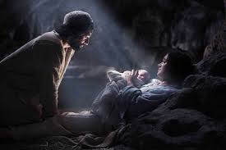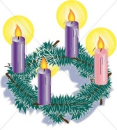

**SCRIPTURE**

**Psalm 27: 13-14** Be strong and brave and wait for the Lord’s help.

**Isaiah 9: 2-3, 6-7** God, you will cause the nation to grow.

**Isaiah 25: 8-9** God will wipe away every tear from every face

**Isaiah 40: 9-11** Look, the Lord God is coming with power.

**Jeremiah 33:14-16** The Lord says, “The time is coming when I will do the things I promised.”

**John 1: 5** The Light shines in the darkness

**Matthew 1:1-25** Jesus came from the family of David. David came from the family of Abraham.

**Luke 1: 38-57** God will always give mercy to those who

worship him.

**OUR BIG QUESTION**

What does it mean to live in hope?

t

**REFLECTION**

Today a Saviour is born!

In the stillness of the night God enters human history

through the birth of his only Son.

He is our peace and hope.

In him we praise God for his

goodness to us in giving us so great a gift.

Amen.

**KEY VOCABULARY**

waiting hopeful Promised one

Messiah prophet

Advent focuses on Jesus’ coming in history and encourages believers to prepare for the Christ who comes each day.

The church is sharing in the long preparation for the Saviour’s first coming, the faithful renew their ardent desire for his second coming.

Christians celebrate the birth of Jesus, the promised one, on 25 December. It is preceded by the season of Advent, a time of preparation.

**HOPE**

Year 5 Topic 3