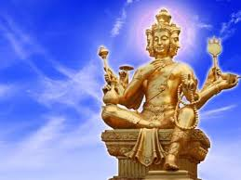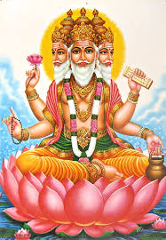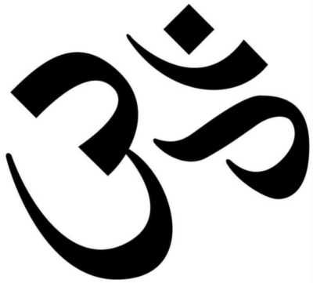

Brahman has three major qualities/trimurti (meaning three gods) Brahma, Vishnu and Shiva.

**KEY VOCABULARY**

Brahman

pilgrimage

supreme God

Hindus have a belief in one supreme Being called Brahman who takes many different visible forms.

**OUR BIG QUESTION**

What is special about Brahman?

It is a flexible religion which allows people to express their belief and worship in different ways.

Hinduism has no known founder.

Hinduism is one of the oldest religions of the world.

**HINDUISM – Brahman**

Year 5