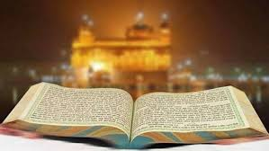

**KEY VOCABULARY**

Special clothes

Guru

Sikh

The Guru Granth Sahib is a collection of teachings and hymns.

It was decided the last Guru would be the scriptures, the living teacher.

Sikhism is the fifth largest world religion.

Sikhs believe in one God and teachings of the ten Gurus.

Sikhism was founded by Guru Nana in India.

**OUR BIG QUESTION**

How are special books treated?

**SIKHISM – Guru Granth Sahib**

Years 3 and 4