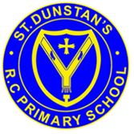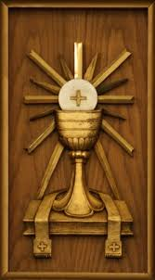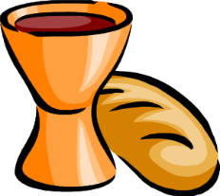

**SCRIPTURE**

**Matthew 5: 45-48** Your Father causes the sun to rise on good people and on bad people. If you love only the people who love you, then you will get no reward.

**1 Corinthians 11: 24-27** Jesus broke the bread and said, “This is my body; it is for you. Do this to remember me.”

**Romans 12: 8-11** Do not be lazy but work hard. Serve the Lord with all your heart.

**KEY VOCABULARY**

Liturgy of the Word Penitential Act

Lamb of God

Rite Sign of Peace Eucharist

**OUR BIG QUESTION**

What is more important, giving or receiving?

In the Concluding Rite we are sent out to continue the work of Jesus.

We are called to follow the example of Jesus by giving ourselves to others in the world.

When we celebrate the Eucharist Jesus gives himself to us in Word and Sacrament.

**REFLECTION**

Lord Jesus Christ, in you we know the love of God. When we gather in your name, we experience the marvel of your loving presence which challenges us to live for one another. Help us to follow your example so that we may never become complacent. Help us to listen to your constant call to us to continue the work you began, you who lived and died for us. Grant this through your Spirit of Love.

Amen.

**GIVING & RECEIVING**

Years 3 & 4 Topic 5