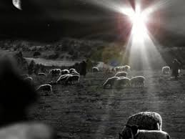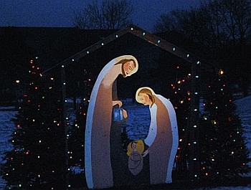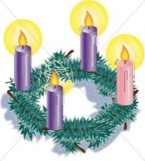

**SCRIPTURE**

**Isaiah 40: 9-11** The Lord takes care of his people like a shepherd. He gathers the people like lambs in his arms.

**Matthew 2: 1-12, 16-18** The wise men went to the house where the child was and bowed down and worshiped the child. They opened the gifts they brought for him. They gave him treasures of gold, frankincense, and myrrh.

**Ephesians 1: 3-6** In Christ, God has given us every spiritual blessing in heaven.

**Philippians 4: 4-9** God’s peace will keep your hearts and minds in Christ Jesus. The peace that God gives is so great

that we cannot understand it.

**KEY VOCABULARY**

friendship loyalty commitment rejoice

peace God’s plan

**REFLECTION**

Today a Saviour is born!

In the stillness of the night God enters human history

through the birth of his only Son.

He is our peace and hope.

In him we praise God for his

goodness to us in giving us so great a gift. Amen.

During the season of Advent, we explore the gift of love and the promise of Jesus’ return at the end of time.

..

Jesus reveals God’s love for humanity and the possibility of friendship.

God’s gift of Jesus is a gift of love to all people of all time.

**OUR BIG QUESTION**

What is so special about gifts?

**GIFT**

Years 3 and 4 Topic 3