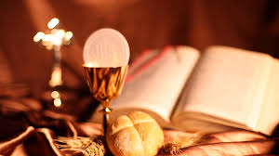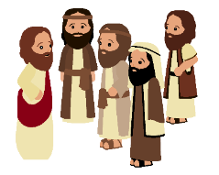

**SCRIPTURE**

**Romans 12: 8-11** Love each other like brothers and sisters. Give your brothers and sisters more honour than you want for yourselves. Do not be lazy but work hard. Serve the Lord with all your heart.

Mark 3: 13-19 Jesus chose 12 men and called them Apostles.

Acts 6: 2-13; 7: 57-60 Saint Stephen’s persecution

**KEY VOCABULARY**

responsibility parish laity ministries

pastoral area deanery service

**OUR BIG QUESTION**

What makes a community?

The whole liturgical life of the Church revolves around the Eucharistic sacrifice and the Sacraments.

Lay people help to build up the local community of the parish.

In the local church, lay people of all ages are called to undertake various roles called ministries.

**REFLECTION**

Lord, you fulfilled the hope of Simeon who did not die

until he had been privileged to

welcome the Messiah.

In Sacramental Celebrations we meet the Risen Christ.

May he continue to give us life.

Amen.

**MISSION**

Years 3 & 4 Topic 4