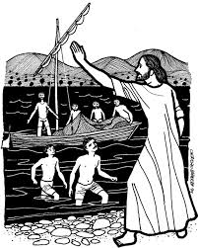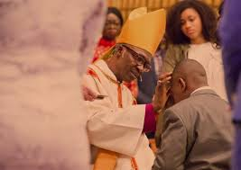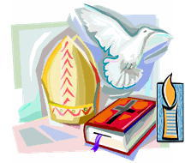

**SCRIPTURE**

**1 Samuel 2: 11, 3: 3-10, 19** Samuel said, “Speak, for your servant is listening.”

**1 Samuel 16: 4-13** Don’t look at how handsome Eliab is…. God does not see the same way people see…The Lord looks at the heart.”

**1 Corinthians** 12: 31 Love is indispensable

**Mark 1: 14-20** Come, follow me,” Jesus said, “and I will send you out to fish for people.”

**1 John 1: 5-7** God is in the light. We should live in the

light, too.

**KEY VOCABULARY**

Sacrament of Confirmation

oil of Chrism mitre

crozier sponsor

Holy Trinity Bishop

**REFLECTION**

Almighty and eternal God,

you keep together those you have united.

Look kindly on all who follow Jesus your Son.

We are all consecrated to you by our common baptism;

make us one in the fullness of faith

and keep us one in the fellowship of love.

Amen.

**OUR BIG QUESTION**

How do people respond to being called?

The oil used in the sacramental celebration is called Chrism, consecrated by the bishop during the Chrism Mass on Holy Thursday.

Confirmation is the full outpouring of the Holy Spirit as granted to the apostles on the day of Pentecost.

Through Baptism and Confirmation people are given the gift of the Holy Spirit and are called to respond in their lives.

**CALLED**

Years 3 and 4 Topic 2