**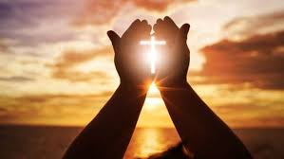****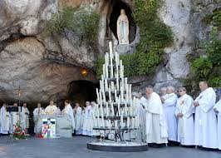**

**SCRIPTURE**

**Luke 2: 11** your Saviour was born in David’s town. He is Christ, the Lord.

**Luke 2: 41, 46** Every year Jesus’ parents went to Jerusalem for the Passover Feast.

**Mark 1: 9** At that time Jesus came from the town of Nazareth in Galilee to the place where John was. John baptised Jesus in the Jordan River.

**Matthew 5: 1-12** The Beatitudes

**Psalm 24: 1** The earth and everything in it belong to the Lord.

The world and all its people belong to him.

Romans 5: 5

**OUR BIG QUESTION**

What makes a place special?

The Christian community has many special places: places where people gather for prayer and worship.

Pilgrimages evoke our earthly journey towards heaven and are traditionally very special occasions for renewal in prayer.

Places are holy because of their association with Jesus or holy people; places of pilgrimage.

**KEY VOCABULARY**

world pilgrim pilgrimage universal

temple Nazareth

**REFLECTION**

Creator God, in your hands you hold the depths of the earth and the heights of the mountains, for all creation belongs to you. Grant us grace to cherish your world and wisdom to nurture its resources. Save us from the desire to control what is not ours and the impulse to possess what is not ours and the impulse to possess what is there to share.

Amen.

**SPECIAL PLACES**

Years 3 and 4 Topic 9