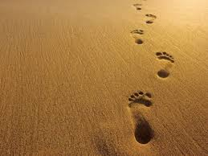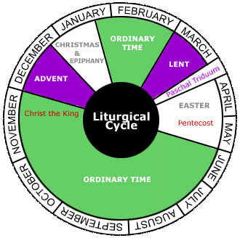

**SCRIPTURE**

Psalm 84 The Lord God is like our sun and shield. The Lord gives us kindness and glory.

Psalm 118 Thank the Lord because he is good. His love continues forever.

Psalm 122: 1-9 Jerusalem is built as a city where friends can come together. The people from the tribes go up there. The tribes belong to the Lord. It is the rule to praise the Lord at Jerusalem,

**OUR BIG QUESTION**

Is life a journey?

Sacraments are more formal special moments: signs of ‘God-with-us’, who journeys with his people; signs of strength and blessing for life.

The Christian life is about journeying with Christ and sharing his way of life.

The Church’s year celebrates the key elements of Christ’s life.

**KEY VOCABULARY**

calendar seasons journey ordinary time

feast day Our Lady

**REFLECTION**

Lord, you fulfilled the hope of Simeon who did not die until he had been privileged to

welcome the Messiah. In Sacramental Celebrations we meet the Risen Christ.

May he continue to give us life.

Amen.

**JOURNEYS**

Years 3 and 4 Topic 4