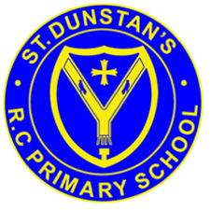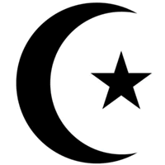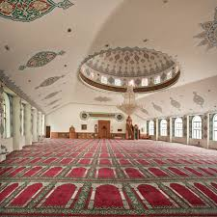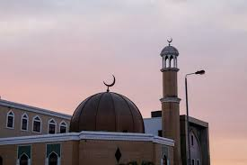

For Muslims, their mosque is a very special place, they go there to pray, to meet people and study.

A Muslim place of worship is called a mosque, which means a place to bow down.

There are two main groups of Muslims, Shi’ah and Sunni.

Muslims believe in one God, Allah.

Muslims are followers of the religion Islam, which began in Saudi Arabia.

**OUR BIG QUESTION**

How would you recognise a mosque?

**KEY VOCABULARY**

Mosque imam

Makkah

Arabic

**ISLAM – The Mosque**

Years 3 and 4