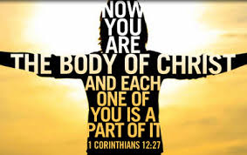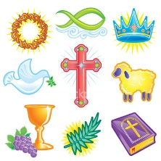

**SCRIPTURE**

Romans 12: 8-13 *Be real in your love for one another*

Ephesians 5: 1-9; and 6: 1-4. *Obey your parents*

John 13:34-35 *You must love one another as I have loved you*

Col 3:12-17 God loves you and has chosen you. You are holy people

Luke 2: 39-40 *When Joseph and Mary returned to their hometown of Nazareth in Galilee. The child grew and became strong; he was full of wisdom, and God's blessings* *were upon him.*

g

At home one learns endurance and the joy of work, love, forgiveness and above all, divine worship in prayer.

God is present in every home. This is expressed in the love that binds the family together within the home through good times and bad times.

**OUR BIG QUESTION**

What makes a house a home?

The home is the first school of Christian life and ‘a school for human enrichment.’

**HOMES**

Years 3 and 4 Topic 1

**REFLECTION**

Father, creator of all,

you ‘ordered the earth’ to bring forth life   
and crowned its goodness by

creating family life.

Teach us the beauty of human love,  
show us the value of family life

and help us to live in peace   
with everyone.   
Amen.

**KEY VOCABULARY**

home love family difference respect joys sorrows community family