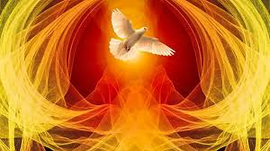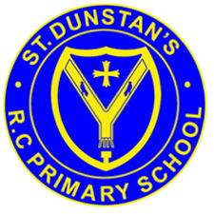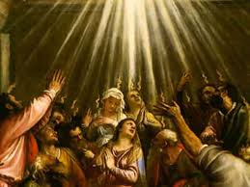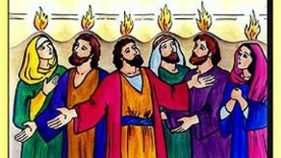

**SCRIPTURE**

Matthew 28: 1-10 Jesus rises from the dead

John 16: 5-7 The promise of the Holy Spirit

1 Corinthians 12: 4-8, 11 Something from the Spirit can be seen in each person, to help everyone.

Acts 1: 6-11 Jesus’ Ascension

Acts 2: 1-18, 43 This noise filled the whole house where they were sitting. They saw something that looked like flames of fire. The flames were separated and stood over each person there. They were all filled with the Holy Spirit, and they began to speak different languages. The Holy Spirit was giving them the power to speak these languages.

**OUR BIG QUESTION**

What is the use of energy?

**KEY VOCABULARY**

warmth wind energy power gifts

Holy Spirit Rosary Glorious Mysteries

At Pentecost, the disciples were filled by the gifts of the Holy Spirit and went out courageously to carry the Gospel of Jesus to the whole world.

The symbols used for the Holy Spirit – wind and fire – are symbols of power and energy.

Christians believe that the gift of the Holy Spirit within them gives them energy and the power to live the way of Jesus.

**REFLECTION**

Father, pour out your Spirit upon your people,

and grant us a new vision of your glory,

a new faithfulness to your Word and a new

consecration to your service, that your love

may grow among us, and your kingdom

come: through Christ our Lord.

Amen.

**ENERGY**

Years 3 and 4 Topic 7