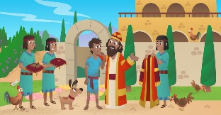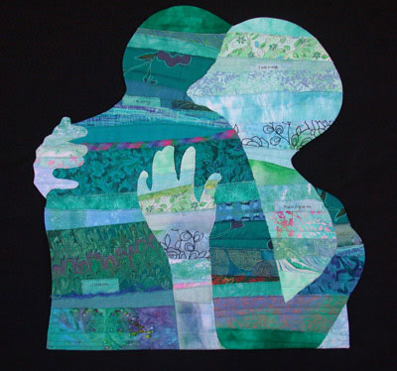

**SCRIPTURE**

1 Thessalonians 5: 12-18 Always be happy. Never stop praying. Give thanks whatever happens. That is what God wants for you in Christ Jesus.

Luke 15: 11-32 The Parable of the Prodigal Son.

**REFLECTION**

I have chosen the way of faithfulness;   
I set your ordinances before me.  
I cling to your decrees,  
O Lord; let me not be put to shame.  
I run the way of your commandments,   
for you enlarge my understanding.  
Teach me, O Lord, the way of your statutes,   
and I will observe it to the end.  
Give me understanding that I may keep your law   
and observe it with my whole heart.  
Amen.

**OUR BIG QUESTION**

What helps you make good choices?

Through and in Christ, every human being is offered the power to reach out in forgiveness and peace, to receive and to offer reconciliation.

The Sacrament of Reconciliation is a celebration of God’s love and mercy; it is about the forgiveness of sin and being reconciled with God and one another.

When making a choice, it is important to examine your conscience in order to make a good choice and minimise bad effects for ourselves and others.

**KEY VOCABULARY**

Reconciliation Confession conscience sorrow

penance sin repentance absolution

**CHOICES**

Years 3 and 4Topic 8