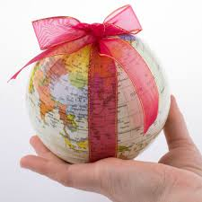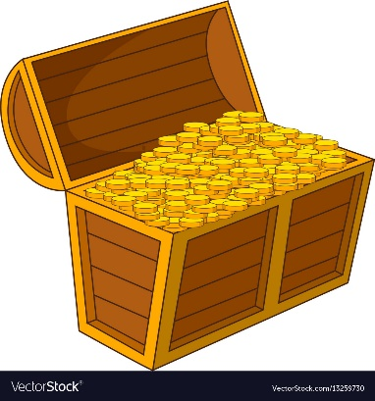

**SCRIPTURE**

Genesis 1:3, 9, 20, 24, 26 Creation Story

Psalm 19: 1-6 The heavens tell the glory of God and the skies announce what his hands have made.

Luke 12: 27-28 Look at the wild flowers. See how they grow…

Isaiah 41: 17-18 The poor and needy people look for water…. But the Lord, will answer their prayers.

Psalm 147: 4-5, 8-9, 15-18 He counts the stars and names each one. Our Lord is great and very powerful.

There is no limit to what he knows.

**OUR BIG QUESTION**

Is the world a treasure?

The world is God’s treasure given to us.

Appreciating that all is gift leads us to treasure everything in life.

Christians believe that life is God’s gift.

**REFLECTION**

Creator God, in your hands you hold the depths of the earth and the heights of the mountains, for all creation belongs to you. Grant us grace to cherish your world and wisdom to nurture its resources. Save us from the desire to control what is not ours and the impulse to possess what is not ours and the impulse to possess what is there to share.

Amen.

**KEY VOCABULARY**

treasure gift care love protect respect preserve

creation precious

**TREASURES**

Years 1 and 2 Topic 9