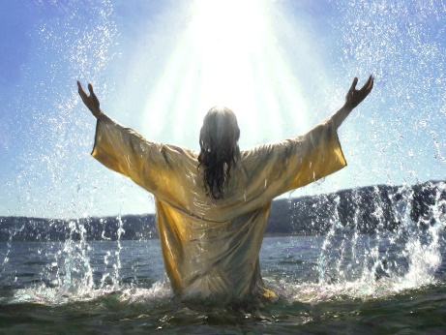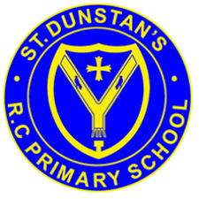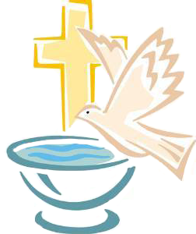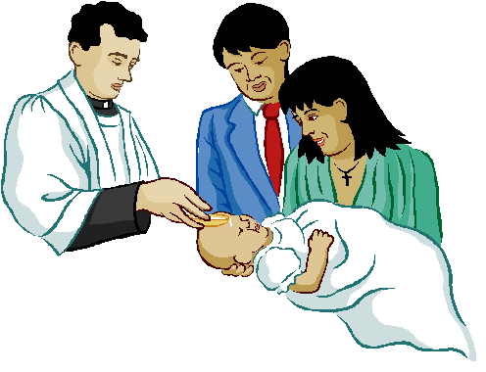

**KEY VOCABULARY**

garment candle font chrism

Good News

sign symbols

**REFLECTION**

Almighty and eternal God,

you keep together those you have united.

Look kindly on all who follow Jesus your Son.

We are all consecrated to you by our common baptism;

make us one in the fullness of faith

and keep us one in the fellowship of love.

Amen.

**OUR BIG QUESTION**

Are signs and symbols important?

Not all children may be baptised. Not only babies are baptised.

Special symbols are called ‘sacraments’ because they put us in touch in a powerful way with the life, ministry, death and resurrection of Jesus and they point to his continued presence among us today.

For Christians, signs and symbols speak of God’s mysterious presence in the world and in our lives.

**SIGNS & SYMBOLS**

Years 1 and 2 Topic 2

**SCRIPTURE**

John 3:5

‘*I am telling you the truth,’ replied Jesus. ‘No one can enter the Kingdom of God without being born of water and the Spirit.’*