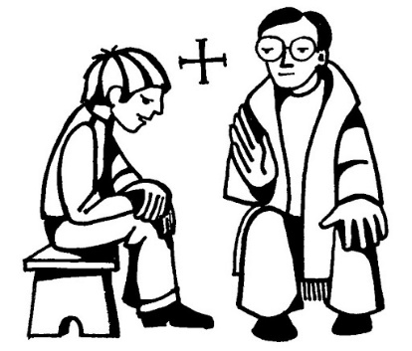****

**SCRIPTURE**

**John 15: 12** This is my command: Love each other as I have loved you.

**Colossians 3: 10-17** God has chosen you and made you his holy people. He loves you. So always do these things: Show mercy to others; be kind, humble, gentle, and patient.

**Matthew 18: 21-22** Jesus said, “I tell you, you must forgive someone more than 7 times. You must forgive him even if he does wrong to you 70 times 7.

**OUR BIG QUESTION**

Do we need rules?

The Sacrament of Reconciliation grants pardon and peace.

Christians should follow God’s law and through love, express sorrow for wrong doing.

For Christians, Christ’s rule of love of God and neighbour offers freedom and happiness.

**KEY VOCABULARY**

sorry forgive right wrong choices sin consequences examination of conscience

**REFLECTION**

I have chosen the way of faithfulness;   
I set your ordinances before me.  
I cling to your decrees,  
O Lord; let me not be put to shame.  
I run the way of your commandments,   
for you enlarge my understanding.  
Teach me, O Lord, the way of your statutes,   
and I will observe it to the end.  
Give me understanding that I may keep your law   
and observe it with my whole heart.  
Amen.

**RULES**

Years 1 and 2 Topic 8