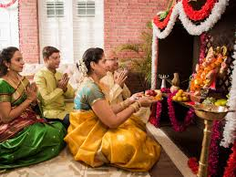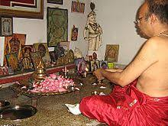

**KEY VOCABULARY**

Puja art

shrine

diva Aum

**OUR BIG QUESTION**

Why would someone have a home shrine?

Most Hindus worship more at home rather than in the Temple.

Hinduism has no known founder.

It is a flexible religion which allows people to express their belief and worship in different ways.

Hinduism is one of the oldest religions of the world.

Hindu families may have shrines in their homes dedicated to a god or gods.

**HINDUISM – Puja**

Years 1 and 2