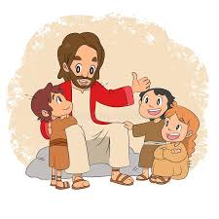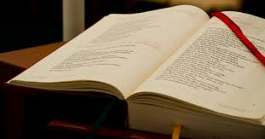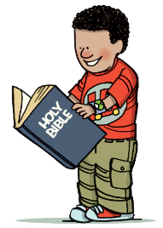

**SCRIPTURE**

**Matthew 3: 13-17 Jesus is Baptised by John**

Jesus was baptised and came up out of the water. Heaven opened, and he saw God’s Spirit coming down on him like a dove. And a voice spoke from heaven. The voice said, “This is my Son and I love him. I am very pleased with him.”

John 13: 34-35 “I give you a new command: Love each other. You must love each other as I have loved you. All people will know that you are my followers if you love each other.”

**OUR BIG QUESTION**

Why do we need books?

**KEY VOCABULARY**

Scripture lectern Gospel Bible New Testament Old Testament genre thurible missal

**REFLECTION**

Lord, you fulfilled the hope of Simeon who did not die until he had been privileged to welcome the Messiah. In Sacramental Celebrations we meet the Risen Christ. May he continue to give us life.

Amen.

The scriptures are the treasured Word of God for the Jewish and Christian communities.

The lectionary which is used at Mass contains the scriptures used by the community throughout the year.

In the sacred books, the Father who is in heaven comes lovingly to meet his children and talk with them.

**BOOKS**

Years 1 and 2 Topic 4