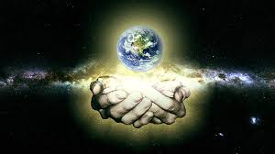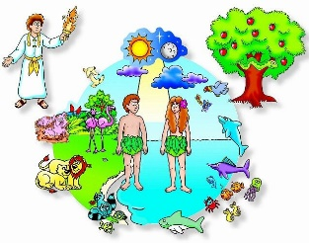

The eternal God gave a beginning to all that exists outside of himself: he alone is Creator.

We often need help to begin anything new.

God is present in every beginning.

**OUR BIG QUESTION**

Who made the world and everything in it?

**BEGINNINGS**

Years 1 and 2 Topic 1





**SCRIPTURE**

**Genesis 1: 1- 9, 20, 24-26** In the beginning God created the sky and the earth….

**Psalm 8: 3-11** I see the moon and stars,

which you created.

**Psalm 139: 14-18** I praise you because you made me in an amazing and wonderful way

**Ephesians 1: 3-5** God decided to make us his own children.

**KEY VOCABULARY**

beginning new start family friend

creation psalm litany

**REFLECTION**

Father, creator of all,

you ‘ordered the earth’ to bring forth life   
and crowned its goodness by

creating family life.

Teach us the beauty of human love,  
show us the value of family life

and help us to live in peace   
with everyone.   
Amen.