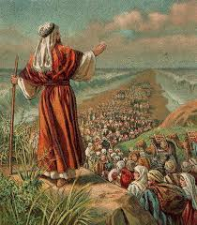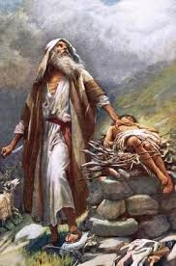

**KEY VOCABULARY**

Abraham Moses

leaders promised

Pharaoh

**OUR BIG QUESTION**

Why is Abraham special?

Abraham helped people understand there is only one God.

Abraham answered God’s call to go on an unknown journey.

Moses led the Jewish people to escape from slavery.

Moses was a descendant of Abraham.

**JUDAISM – Abraham & Moses**

Years 1 and 2

Abraham is the father of the Jewish nation.