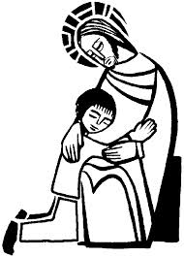

**SCRIPTURE**

**Luke 5: 27-31** They said, “Why do you eat and drink with tax collectors and ‘sinners’?”

Jesus answered them, “Healthy people don’t need a doctor. It is the sick who need a doctor.”

**Luke 19: 1-10** The story of Zacchaeus

**John 13: 34-35** “I give you a new command: Love each other. You must love each other as I have loved you.”

**KEY VOCABULARY**

choice happy sad disappointed sorry forgive

rules wrong right feeling love

**REFLECTION**

I have chosen the way of faithfulness;   
I set your ordinances before me.  
I cling to your decrees,  
O Lord; let me not be put to shame.  
I run the way of your commandments,   
for you enlarge my understanding.  
Teach me, O Lord, the way of your statutes,   
and I will observe it to the end.  
Give me understanding that I may keep your law   
and observe it with my whole heart.  
Amen.

The Church offers the Sacrament of Reconciliation which celebrates God’s unconditional love for us.

**OUR BIG QUESTION**

How do you show you are sorry?

There are times when we need to acknowledge our sorrow for making wrong choices.

For Christians it is important to make choices in the light of our belief in a loving God.

**BEING SORRY**

Years 1 and 2 Topic 8