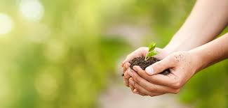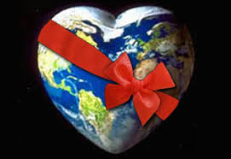

People, the earth, places and things are all a gift from God.

**OUR BIG QUESTION**

What makes our world so beautiful?

**REFLECTION**

Creator God, in your hands you hold the depths of the earth and the heights of the mountains, for all creation belongs to you. Grant us grace to cherish your world and wisdom to nurture its resources. Save us from the desire to control what is not ours and the impulse to possess what is not ours and the impulse to possess what is there to share.

Amen.

**KEY VOCABULARY**

world

care creation responsible

**OUR WORLD**

Nursery and Reception Topic 9

**SCRIPTURE**

Genesis 1: 3, 9, 20, 24−26

The Story of Creation