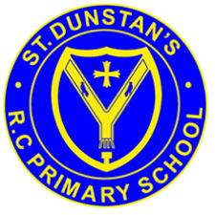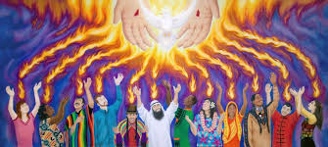

**SCRIPTURE**

**Acts 2: 1-4 The Coming of the Holy Spirit**

When the day of Pentecost came, they were all together in one place. Suddenly a noise came from heaven. It sounded like a strong wind blowing. This noise filled the whole house where they were sitting. They saw something that looked like flames of fire. The flames were separated and stood over each person there. They were all filled with the Holy Spirit, and they began to speak different languages.

**OUR BIG QUESTION**

What is good news?

At Pentecost, the gift of the Holy Spirit is given.

**KEY VOCABULARY**

Pentecost good news sharing flames celebrate birthday

**REFLECTION**

Father, pour out your Spirit upon your people,

and grant us a new vision of your glory,

a new faithfulness to your Word and a new

consecration to your service, that your love

may grow among us, and your kingdom

come: through Christ our Lord.

Amen.

**GOOD NEWS**

Nursery and Reception Topic 7