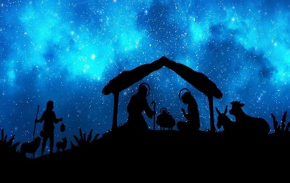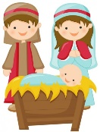

**SCRIPTURE**

**Luke 2: 4-7** Jesus’ birth.

There were no rooms left in the inn. So Mary wrapped the baby with cloths and laid him in a box where animals are fed.

**Luke 2: 8-20** The Shepherd Hear about Jesus

**Matthew 2: 1-12** Wise Men Come to Visit Jesus.

**OUR BIG QUESTION**

Why do we celebrate birthdays?

Advent is a time of waiting for the celebration of Christ’s birth.

**REFLECTION**

Today a Saviour is born!

In the stillness of the night God enters human history

through the birth of his only Son.

He is our peace and hope.

In him we praise God for his

goodness to us in giving us so great a gift. Amen.

**KEY VOCABULARY**

**Advent wreath crib Mary Joseph manger Christmas**

**BIRTHDAY**

Nursery and Reception Topic 3